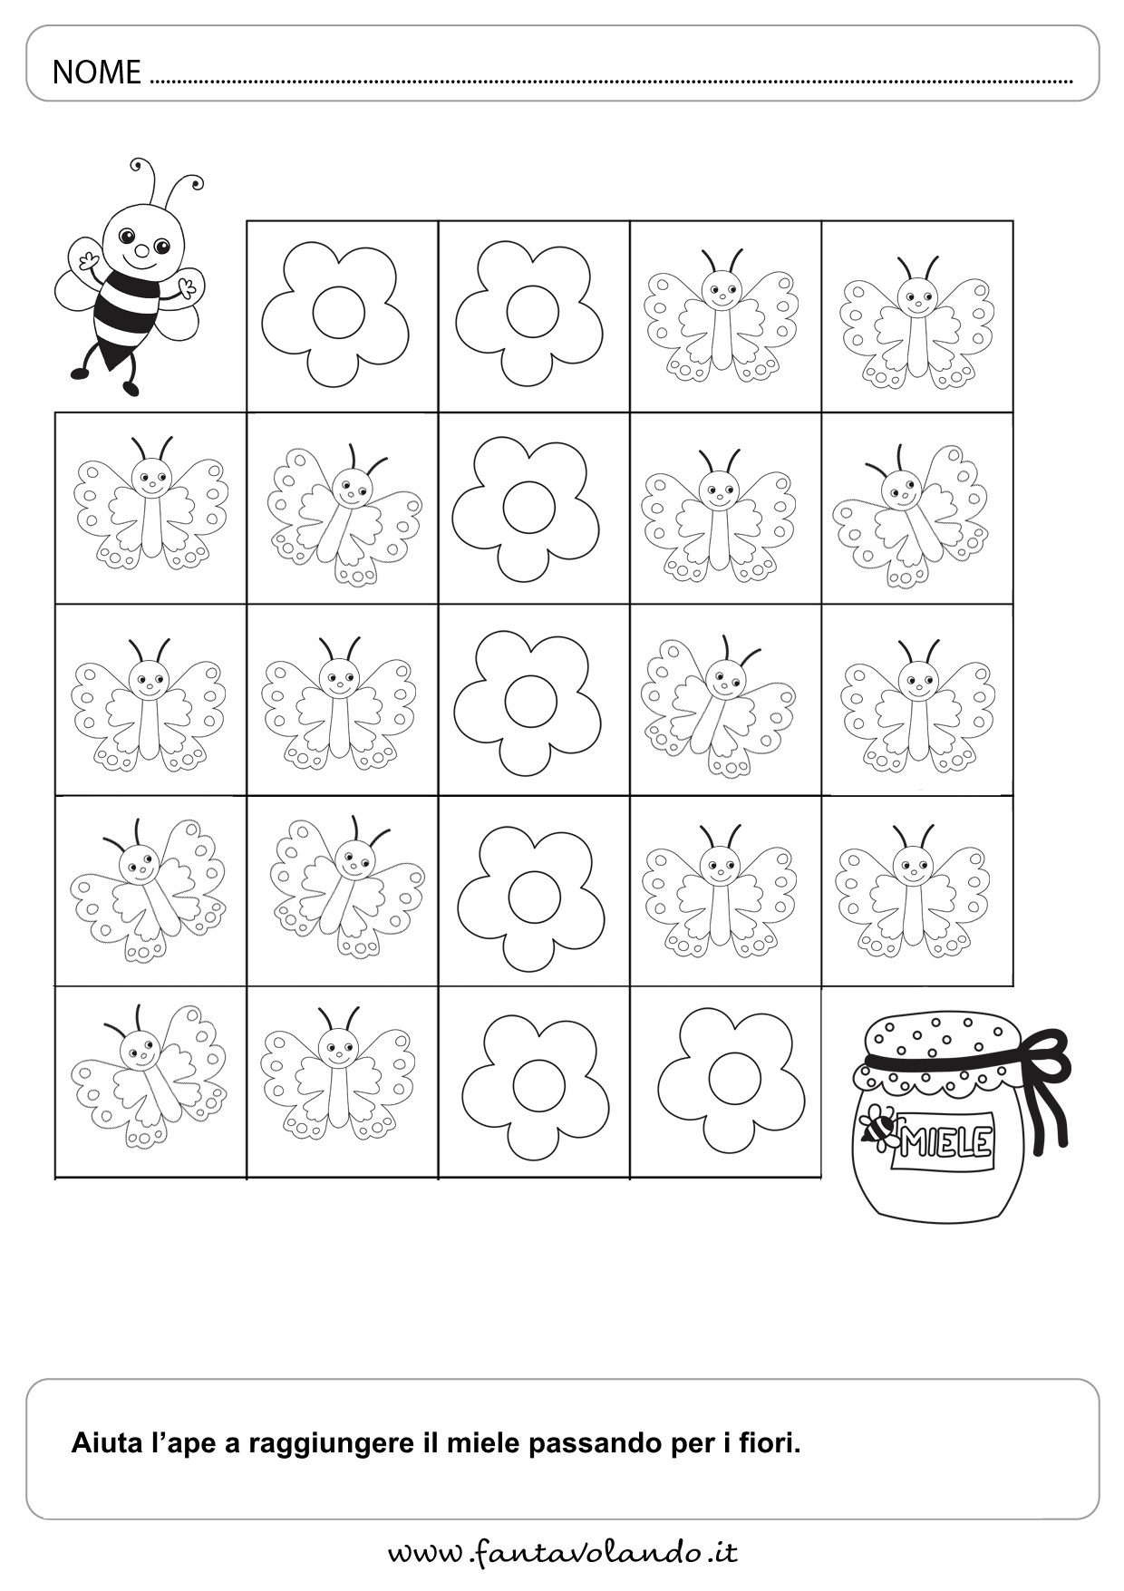

.fa-wta-x/oQ-a-M-do